

Cyberster Internship Program

Internship Report
TRACK: BLUE TEAM
NAME: MUHAMMAD RAZA
INSTRUCTOR: ABDULLAH ZIA
ROLL NUMBER: CSI-B1-121
WEEK 4: pfSense Firewall and Advanced Monitoring

Days 22 and 23 — PfSense Firewall Setup

Installation Walkthrough Of Pfsense
License Screen
When the installer starts the first screen it presents offers license terms for pfSense® software which the user must accept before installation.

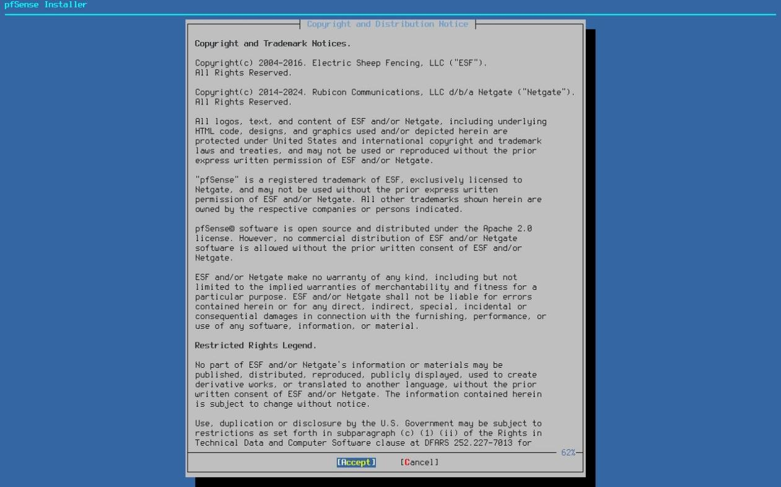
Read the terms carefully. Use the Page Down and Page Up keys to display additional license text. Press Enter to Accept the terms and proceed.

Welcome Menu

Next, the installer prompts to launch rescue options or start the installation process.

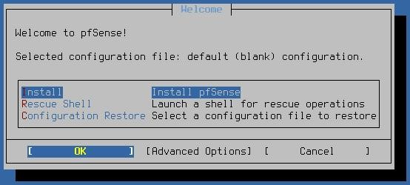
Use the arrow keys to select an option, then press Enter. The options on this screen are:
Install:
Continue installing pfSense software
Rescue Shell:
Starts a basic shell prompt where advanced users can perform tasks to prepare the hardware in ways not possible directly in the installer, or to perform diagnostic tests or repairs on the firewall.
Configuration Restore:

Attempts to restore a configuration file recovered from a prior installation or copied from other media and then use that configuration in the target installation.
The installer will hide this menu option if it cannot locate any configurations to restore.
See Configuration Restore for details.
Advanced Options:
This option is in the bottom row of buttons. It loads another menu which contains extra options to control the behavior of the installer.
See Advanced Options for details.

Configuration Restore¶
The installer searches for available configurations to recover and use for the target installation. This can be an existing prior installation of pfSense software or a configuration file on a FAT/FAT32 partition on a USB drive. The installer lists every configuration file it can locate and offers the user a choice of which to use, or to proceed without recovering a configuration.

Tip
When restoring a configuration from a prior installation, this option also searches for and copies SSH host keys and DHCP lease data to the new installation.

To recover a configuration and copy it to the target installation, use the arrow keys to select it from the list and press the Enter key.
After selecting a configuration to restore, the installer displays this choice on the welcome screen:
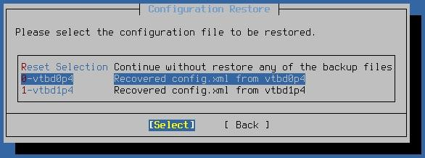
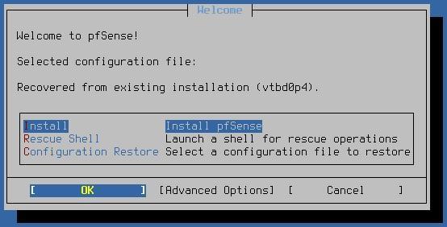
Configuration Restore - List of Configuration Files¶
After selecting a configuration to restore, the installer displays this choice on the welcome screen:

Configuration Restore - Selected Configuration¶
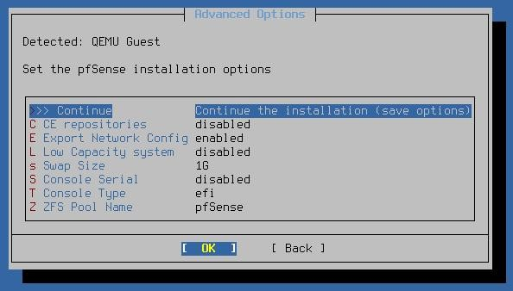
To deselect the configuration file and proceed with a default configuration instead, enter the Configuration Restore menu again and choose Reset Selection.

Advanced Options¶
The options on the Advanced Options menu fine-tune the target installation.

Advanced Options¶
Use the arrow keys to select an option, then press Enter to set or toggle the value. The options on this screen are:
CE Repositories:
For devices eligible to install pfSense Plus software, this option toggles the availability of CE repositories in the list of versions the installer will offer.

This allows someone with a device capable of running pfSense Plus software to install pfSense CE software instead.
Export Network Config:

This option instructs the installer to export its network configuration settings into the default configuration file for the target system during the installation process.
For example, interface assignments along with the WAN and LAN configuration set inside the installer will carry over to the host for a smoother post-installation experience.
The default value is Enabled. The installer automatically disables this option when recovering an existing configuration file.
Low Capacity System:

This option controls whether the installer automatically adjusts certain default options and behaviors when a device has low storage capacity (e.g. only contains disks with less than 4GB capacity).
When enabled or set to automatic (default) and the installer detects a low capacity device, the installer will make the following changes:
Disables Swap
Sets the default file system to UFS
Will not configure EFI unless necessary Sets the default partition method to MBR
Swap Size:

Sets the size of the swap partition the installer creates on the target disk.
Swap space is used for holding crash dump data as well as for virtual memory to supplement available RAM. Enter a value with a size suffix, such as 1G for 1 GiB of swap space. Use a value of 0 to disable swap.

Note
Swap usage can cause a higher volume of disk writes, but the best practice is to at least keep a small swap partition for crash dump data.
Console Serial:
Controls whether the serial console will be enabled on the target installation. Toggles between enabled and disabled.

Sets a specific type of console for the target installation.
Console Type:
:
EFI
EFI console, best suited for systems booting EFI with video and/or serial.
:
Video
Traditional VGA style console.
:
None

Do not set a specific console type.
ZFS Pool Name:
The name the installer uses when it creates the ZFS pool on selected target disks. The default value is pfSense.
After setting options on this menu, choose Continue and OK and the installer will return to the Welcome Menu.

Network Setup¶
As this is an online installer it requires network connectivity to download installation packages from Netgate servers. To configure the network, the installer has to know at a minimum which port is a WAN with external connectivity, and configuration details to reach the Internet.

Note
The installer detects known models of Netgate hardware an automatically assigns the WAN and LAN to their default ports, skipping this manual assignment process and going right to Confirm Network Configuration.
Select WAN Interface¶
The first interface to assign is the WAN interface. This is the interface connected to the upstream network (e.g. Internet, modem, CPE, etc.). The installer presents a list of all detected interfaces and their MAC addresses, along with their current link state.

Use the up/down arrow keys to select the WAN interface and press Enter to continue.
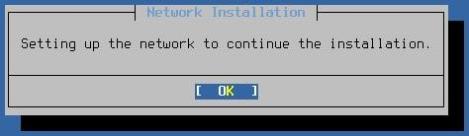

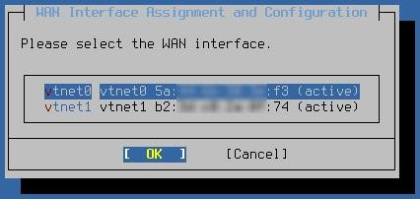

Select WAN Interface¶

Note
When re-visiting this assignment screen later, for example to change the interface assignment or configuration, the list also includes the current assignment (e.g. WAN or LAN) at the end of each row.

Configure WAN Interface¶
The next step is to configure the WAN interface. The installer can utilize DHCP, static IP address, and PPPoE configurations for WAN interfaces. Additionally, interfaces may be VLAN tagged if necessary.

To change the type of interface configuration, select Interface Mode and press the Enter key. To configure a VLAN tag, select VLAN Settings and press the Enter key. To toggle use of the local resolver, select Use local resolver.

These options are explained in further detail in the following sections.

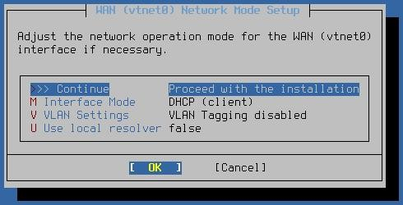

Interface Mode¶

The options on this screen change depending on the selected Interface Mode as certain types require additional configuration.

DHCP Client WAN¶
When the WAN interface is set to DHCP (Client) there are no additional options to configure, the behavior is automatic.

Static IP Address WAN

Changing the Interface Mode to STATIC presents several additional fields to configure static IP address WAN connectivity.

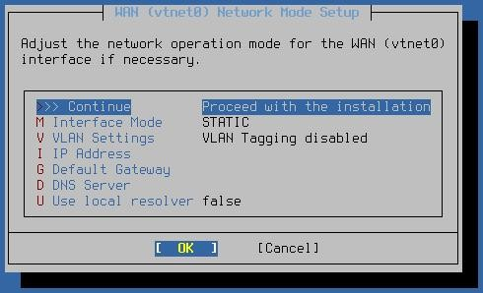
The available settings are:
IP Address:
The IPv4 address and CIDR mask to use for external connectivity.

Note
The installer assumes a CIDR mask of /24 if the address is given without a CIDR mask.
Default Gateway:
The IPv4 address of the default gateway through which the installer can reach the Internet.
DNS Server:
The IPv4 address of a DNS server, usually at the ISP or a public DNS server such as Google, CloudFlare, etc.

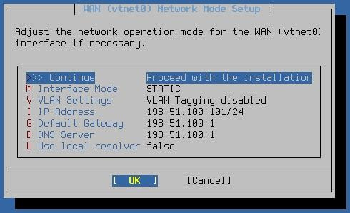
Static IP Address (Configured)¶

The figure above depicts a fully configured static IP address WAN.

PPPoE WAN¶
Changing the Interface Mode to PPPoE presents several additional fields to configure PPPoE WAN connectivity.
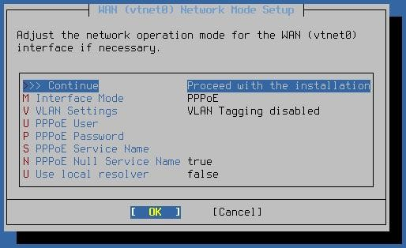

PPPoE WAN¶

The available settings are:
PPPoE User:

The username to use when logging into the upstream PPPoE service.
PPPoE Password:
The password to use when logging into the upstream PPPoE service.
PPPoE Service Name:
Some PPPoE providers require a specific service name to be set in authentication requests. If the provider requires such a value, set it here. Otherwise, leave it empty.
PPPoE Null Service Name:

Configures the PPPoE client to send a null service name instead of an empty name when the PPPoE Service Name is empty. Certain providers may prefer one method or the other when they do not require a service name.
Entering a PPPoE Service Name automatically sets this to false.
Toggling this setting to true erases the PPPoE Service Name.
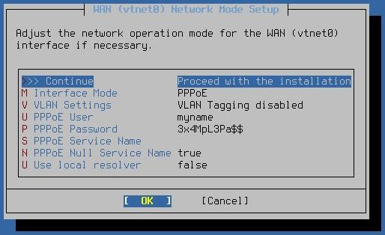
PPPoE WAN (Configured)

The figure above depicts a configured PPPoE WAN.

VLAN Configuration¶
Each interface can be optionally configured to use a VLAN tag when communicating with the rest of the network connected to that interface.

To use a VLAN tag, first select VLAN Settings from the interface configuration screen to reach the VLAN settings screen.

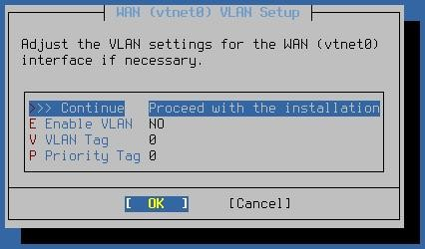
VLAN Configuration¶

The VLAN configuration screen controls how installer uses VLANs on an interface. The following options are available:
Enable VLAN:
Enables or disables VLAN tagging for the interface.
VLAN Tag:
Sets the VLAN tag for traffic on the interface.
Priority Tag:
Sets a VLAN priority value.
Select OK to return to the interface configuration.

Use Local Resolver¶
The Use Local Resolver option is present for every WAN type. It toggles the use of a local DNS resolver (Unbound) to handle DNS resolution rather than querying upstream DNS servers directly.

Select LAN Interface¶
The next step is to select the LAN interface. This is used for connecting to the installer from a local network if needed. While not used in this particular walkthrough, future installer features will rely on having a working LAN configuration, and it can also make obtaining information about installation problems easier to gather when obtaining assistance.

Selecting None will proceed without configuring a LAN, which is acceptable for installing from the console.

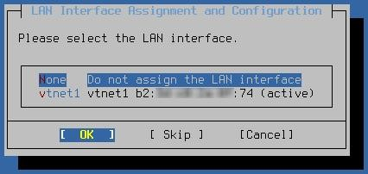
Select LAN Interface if necessary

Note
When re-visiting this assignment screen later, for example to change the interface assignment or configuration, the list also includes the current assignment (e.g. WAN or LAN) at the end of each row.

Configure LAN Interface¶
The options to configure the LAN are similar to a WAN but not identical.
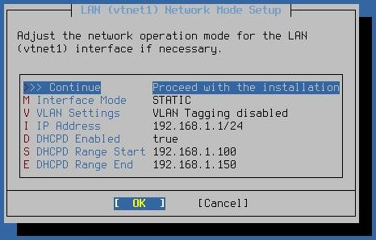

LAN Interface Configuration

The following options are available when configuring the LAN interface:
Interface Mode:
Select between DHCP Client and Static IP Address configuration types.
VLAN Settings:
Enter VLAN Configuration mode for this interface.
IP Address:

Configure a static IP address and CIDR mask for the LAN. Default is 192.168.1.1/24.
DHCPD Enabled:
Toggles DHCP server behavior off/on (default: on)

Note
This option, along with the range start/end, are only available when LAN is set to a static IP address configuration.
DHCPD Range Start:
Sets the starting address of the LAN DHCP range. Default is 192.168.1.100.
DHCPD Range End:
Sets the ending address of the LAN DHCP range. Default is 192.168.1.150.

Confirm Network Configuration¶
This screen lists the current interface assignments, either after manual assignment or from being assigned automatically for known models of Netgate hardware.
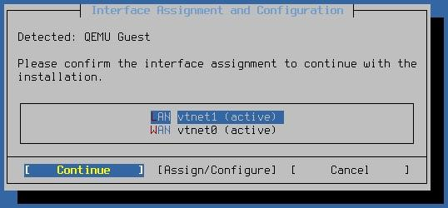

Confirm Network Configuration¶

If the default settings are OK, then choose to Continue from here by selecting it with the left/right arrows and pressing the Enter key.

The default settings are a DHCP client WAN, static IP Address LAN on 192.168.1.1/24 with DHCP server enabled on LAN from 192.168.1.100 to 192.168.1.150.

To change the interface assignments or configuration, select the interface with the up and down arrows and then use the left/right arrows to highlight Assign/Configure then press the Enter key. Refer to the previous sections for information on how to assign and configure each interface.

At this point the installer should have Internet connectivity.

Ineligible Device Prompt¶
The installer gathers information about the device and communicates with Netgate servers to determine if the device is eligible to run pfSense Plus software. If the device is eligible, it moves forward to
the filesystem selection screen. If the device is not eligible, the installer displays a prompt informing the user of this fact.

Warning
If the installer is unable to contact Netgate servers it will display an error saying “Cannot verify the eligibility of this system, please try again.” For suggestions on how to correct that, see Installer Network Connectivity Problems.

If the device does not have an active subscription for pfSense Plus software, one can be purchased at this time by visiting https://www.netgate.com/purchase-plus and entering the Netgate Device ID (NDI), which is listed on this screen of the installer as well.

After subscribing, choose the Retry Validation option to allow the installer to check the subscription status again.
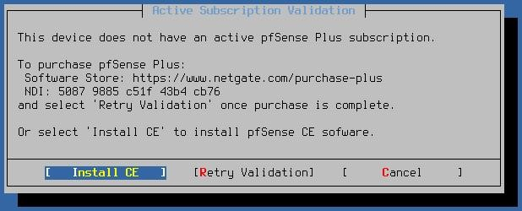
Prompt displayed on systems not yet eligible to run pfSense Plus software

Alternately, users can choose the Install CE option to install pfSense CE Software, and that installation can upgrade to pfSense Plus software later after completing the subscription process.

File System and Partition Settings¶
After verifying the subscription, the next step is to choose the file system and partition type. The available options are:

File System:
The type of file system to use on the target disk.
:
ZFS
A robust modern file system with many advanced features, such as boot environments, but it uses a lot more resources. Even so, this is the default and best practice choice for nearly all cases.

An older file system that works well but can be fragile when it comes to sudden interruptions such as power loss. It uses less resources, but also doesn’t have modern features such as boot environments.
:
UFS
Partition Scheme:

The partition scheme to use on the target disk.
:
GPT
A modern partitioning method compatible with most modern AMD64 devices, but in rare cases it can have issues with older BIOS implementations. This is the default choice as there are very few incompatible modern devices.

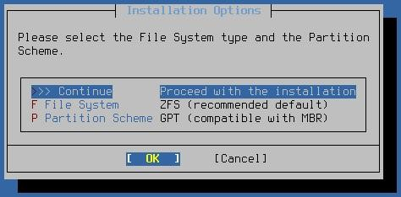
A more basic partition scheme but one which is more widely compatible. This is also used on ARM-based systems.
:
MBR

File System and Partition Options

The process varies slightly depending on the selected filesystem type, so follow the section below that matches the filesystem type to be used by this firewall and then return to this document to complete the steps after.

- ZFS
- UFS

Advanced Disk Options¶
When selecting disks for either UFS or ZFS the installer offers an Advanced Options selection with additional disk operations.

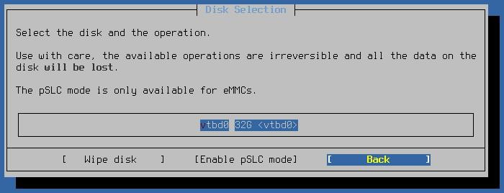
Advanced Disk Options¶

Wipe Disks

This option clears partition and filesystem metadata from the selected disk, effectively making the operating system see the disk as empty.

On devices with both built-in and add-on storage, this is useful for making sure that a previous installation on an unused disk does not conflict with the new installation. For example, if a device has both eMMC storage and an NVMe SSD, the eMMC disk should be wiped, so the device only uses the SSD.

See also
Troubleshooting Multiple Disks

Enable pSLC Mode¶
Some devices include eMMC disks with a “pseudo single-level cell” (pSLC) mode, which greatly increases write endurance at the cost of reduced usable capacity. Devices in pSLC mode can also be read twice as fast as triple-level cell (TLC) devices and written at six times the speed.

Danger
Changing a disk to pSLC mode is PERMANENT and CANNOT be reversed. Proceed with caution.

Warning
Disks can only change to pSLC mode if they are capable of using pSLC mode and have a low write count. The exact write count threshold varies by device.

The installer attempts to set this mode on the disk, but there is no mechanism for the installer to detect pSLC mode compatibility or the write threshold.

If the disk still shows the original capacity after enabling pSLC mode and power cycling the device, it either is not compatible with pSLC mode or its write cycle count was too high.

Switching a disk with multi-level cell (MLC) storage to pSLC mode increases its endurance from approximately 3,000 erasures per sector to 30,000, but the disk loses half of its usable capacity. For example, a 32GB MLC eMMC disk becomes a 16GB pSLC eMMC disk.

Switching a disk with triple-level cell (TLC) storage to pSLC mode increases its endurance from approximately 3,000 erasures per sector to 100,000, but the disk loses two thirds of its usable capacity. For example, a 32GB TLC eMMC disk becomes a 9GB pSLC eMMC disk.

Final Confirmation¶
After selecting the target disk the installer prompts for confirmation one final time before it makes destructive changes to the disk.

Danger
Choosing to continue from this point will destroy anything left on the target disk!
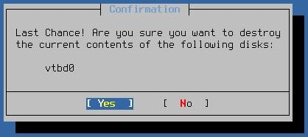

Final Confirmation before Installing

Version Selection¶
At this point the installer presents a list of pfSense software that this device is eligible to run. This list will typically include the current version of pfSense software and one prior release. Depending on the current status of an upcoming release cycle, the installer may also offer development snapshots.

Select the version to install from the list with the up/down arrow keys, select OK with the left/right arrow keys, then press Enter

Tip

In most cases the correct selection will be the one labeled “Current Stable Version”.

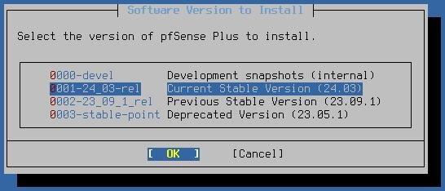
Select Software
Version to Install

Installation¶

After picking the version, the installer proceeds to download the installation data for that version and installs it on the target disk.

Sit back, wait, and have a few sips of a refreshing beverage while the installation process formats the drive(s) and copies pfSense software files to the target disk(s).

The installer displays the output from this process as it works. When finished, the installed presents an OK button which will continue to post-installation tasks.

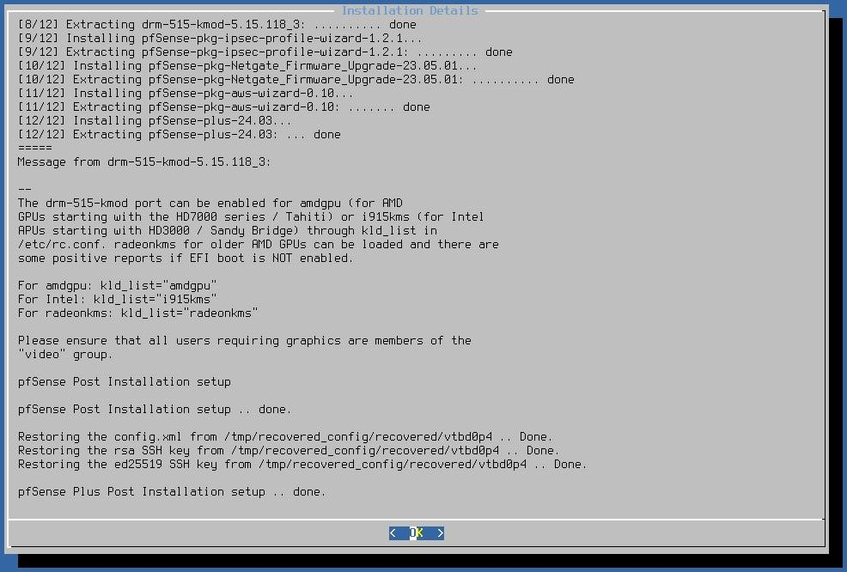

Output After Installation Completes¶

Finish Up

At this point the installation is complete. The installer will prompt one final time to either reboot into the new installation or to start a shell prompt for any manual adjustments advanced users may wish to make.
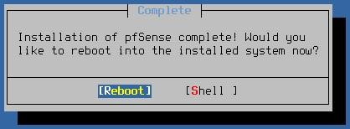
Reboot Prompt¶
Remove the installation media from the firewall during the reboot. The ideal time to remove it is while the hardware is initializing, but before it boots from the disk.
Once the device has booted from its own internal disk the device is ready for use. Congratulations, the installation is complete!

Interface Status and Network Gateway Overview

After completing the initial installation, the first priority was to configure pfSense as the primary network gateway. This screenshot displays the main pfSense dashboard, showing that both the WAN (External) and LAN (Internal Lab Network) interfaces are fully operational. The traffic statistics panel is a critical component here, as it provides real-time confirmation that data is being routed correctly through the virtual environment. By establishing these interfaces, I have created a clear perimeter between the external internet and my internal security lab, which includes my Kali Linux and Ubuntu Manager.
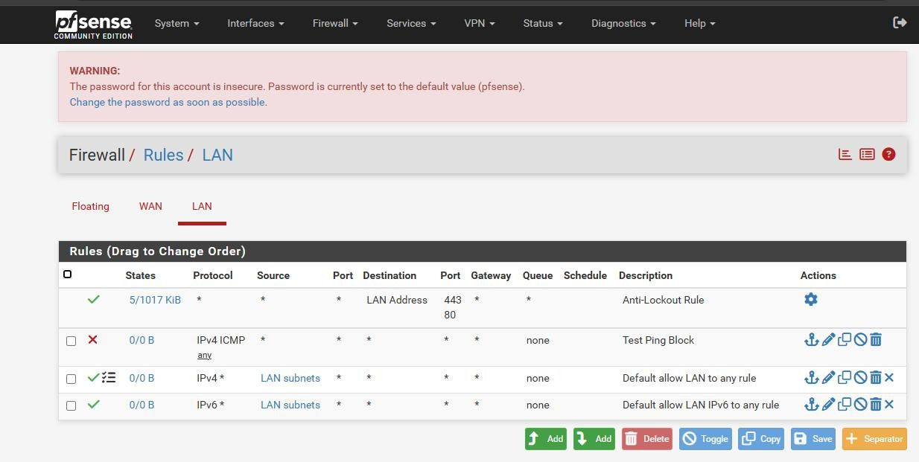
2. LAN Firewall Policy and Logging Configuration
To secure the internal network, I implemented specific firewall rules on the LAN interface to control traffic flow. As shown in the configuration screenshot, I created rules to allow standard DNS and web traffic while strictly blocking and logging suspicious activities, such as unauthorized port scans from the

Kali Linux VM. I specifically enabled the 'Log' feature for each rule; this is a vital step because, without logging, the firewall would drop or pass packets silently. By enabling this, I ensure that pfSense generates a syslog message for every event, which is then forwarded to the Wazuh Manager for further analysis.
Configured Firewall Rules & Justifications:
Rule 1: Block and Log Internal Scanning (Nmap)
Action: Block | Source: Kali Linux IP | Protocol: Any
Why I added it: I created this rule to detect and drop aggressive reconnaissance attempts from the Kali Linux VM. This rule is essential for testing the Wazuh Decoder and ensuring that "Block" events successfully trigger security alerts on the dashboard.
Rule 2: Allow and Log DNS Traffic
Action: Pass | Destination Port: 53 (UDP/TCP)
Why I added it: This rule allows my lab assets to resolve domain names for updates and research. I enabled logging for this "Pass" rule to monitor for any suspicious DNS queries or potential data exfiltration attempts.
Rule 3: Allow and Log Web Traffic (HTTP/HTTPS)
Action: Pass | Destination Port: 80, 443 (TCP)
Why I added it: This provides the Ubuntu Manager and other VMs with standard internet access.

Logging this traffic is vital for maintaining an audit trail of all outbound connections initiated from the secure zone.

Days 24 and 25 — Threat Intelligence Integration
Introduction
In this phase, the lab environment was enhanced by integrating threat intelligence and improving detection capabilities within Wazuh. While previous tasks focused on collecting logs and monitoring systems, this stage introduced external intelligence sources to provide additional context to alerts. This means that instead of only detecting events, the system can now help determine whether those events are associated with known malicious activity.
The main components implemented in this phase included:
- File Integrity Monitoring (FIM)
  - VirusTotal integration
- URLhaus threat feed (CDB)
- MITRE ATT&CK mapping
This phase is critical in SOC operations because it connects raw alerts with real-world threat data, enabling better decision-making and prioritization.
- File Integrity Monitoring (FIM)
  - Overview
File Integrity Monitoring is used to track changes in files such as creation, deletion, and modification. It is especially useful for

detecting unauthorized changes that may indicate compromise or malicious activity.
  - Testing
To validate FIM functionality, test files were created.
  - Results
Wazuh generated alerts with the following details:
    - Rule ID: 554
    - Event Type: File added
- Severity: Medium
- File path correctly recorded
  - Analysis These results confirm that:
    - Wazuh continuously monitors system directories
- File changes are detected immediately
- Relevant details such as file location and timestamp are captured
  - Importance FIM plays an important role in security by:
    - Detecting unauthorized file changes
- Identifying potential malware installation
  - Supporting forensic analysis
- VirusTotal Integration
  - Overview
VirusTotal is a threat intelligence platform that analyzes files using multiple antivirus engines. Integrating it with Wazuh allows automatic validation of file hashes detected by FIM. ii. Configuration

The integration was configured in Wazuh so that whenever a file change occurs, its hash is automatically sent to VirusTotal for analysis.
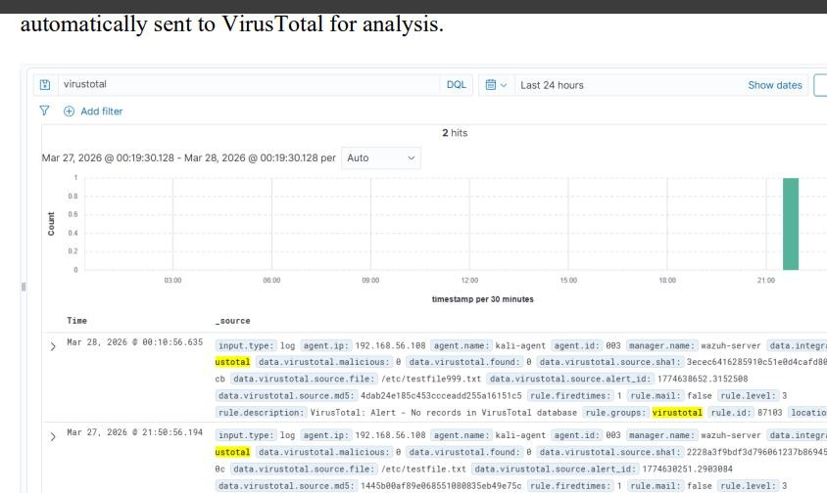
iii. Testing Process
- A file was created in the monitored directory
- Wazuh generated an alert
- The file hash was extracted
- The hash was sent to VirusTotal From the Wazuh dashboard:
iv. Analysis This indicates that:
- The integration is functioning correctly
- The file hash was successfully checked
- URLhaus Threat Feed (CDB)

Overview
URLhaus is a public threat intelligence feed that provides lists of malicious URLs associated with malware distribution. In this lab, it was integrated using Wazuh’s CDB feature.

Configuration
The integration was configured in Wazuh so that whenever a file change occurs, its hash is automatically sent to VirusTotal for analysis.
  - Testing Process
- A file was created in the monitored directory
  - Wazuh generated an alert
- The file hash was extracted
- The hash was sent to VirusTotal From the Wazuh dashboard:

  - Analysis This indicates that:
- The integration is functioning correctly
- The file hash was successfully checked

- URLhaus Threat Feed (CDB)
  - Overview
URLhaus is a public threat intelligence feed that provides lists of malicious URLs associated with malware distribution. In this lab, it was integrated using Wazuh’s CDB feature.

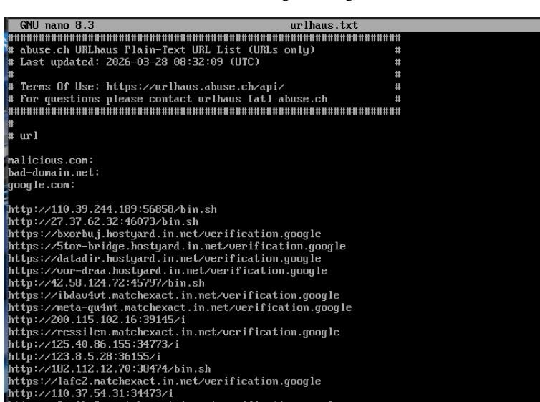
  - Configuration
- URLhaus feed was downloaded
- Stored locally in the Wazuh system
- A custom rule was added in local_rules.xml to match URLs

  - Testing Malicious U
URLs were tested using:
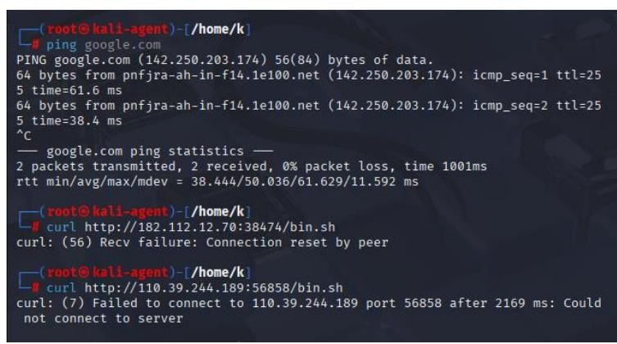
  - Observed Results • No alerts were generated
- Connections failed or were reset Threat Intelligence (URLhaus CDB Feed)

A custom threat intelligence feed using URLhaus was configured in Wazuh to detect malicious URLs. The feed was successfully loaded and integrated into the system. During testing, multiple URLs from the feed were used; however, no alerts were generated because the URLs were unreachable or inactive. This behavior is expected, as many malicious URLs are taken down or become unavailable over time. Despite this, the configuration and integration of the threat feed were verified to be correctly implemented.
- MITRE ATT&CK Mapping

Overview
MITRE ATT&CK is a framework that categorizes attacker techniques based on real-world behavior. Wazuh maps alerts to MITRE techniques to provide context.
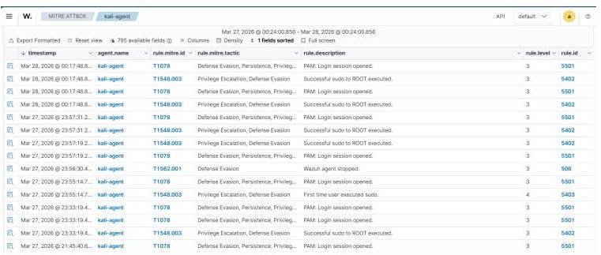
  - Observed Techniques

Technique ID | Description
T1078 | Valid Account
T1548.003T1562.001 | Privilage Escalation
 | Defense Evasion
  - Events Detected
    - PAM login events
    - Sudo commands
- User privilege changes

  - Analysis These mappings show:
    - Use of valid credentials (possible misuse)
- Elevation of privileges
- Potential attacker activity
  - Importance MITRE mapping helps analysts:
- Understand attacker behavior
- Categorize alerts systematically
- Improve detection and response strategies
  - Results and Observations After completing this phase:
- File changes were successfully detected
- VirusTotal integration worked correctly
- Threat intelligence enrichment was applied
- MITRE ATT&CK mapping provided behavioral context
- URLhaus feed was configured but did not generate alerts
Days 26 and 27 — Vulnerability Assessment with Wazuh

Executive Summary of Vulnerability Scans
I enabled the vulnerability-detection module in the Wazuh Manager’s ossec.conf and synchronized the NVD (National Vulnerability Database) feed. After ensuring the syscollector

module was active on both endpoints, a full software inventory scan was performed.
Agent 01: Kali (Linux)
Total CVEs Found: [e.g., 42]
Severity Distribution: * Critical: [e.g., 3] | High: [e.g., 10] | Medium: [e.g., 22] | Low: [e.g., 7]
Highest CVSS Score: 9.8 (Critical)

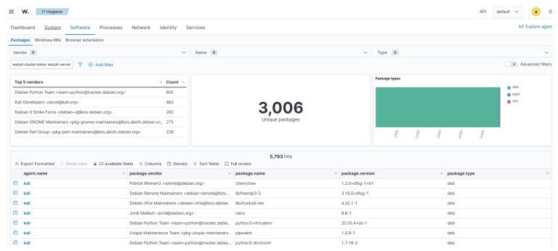

Agent 02: Windows 11 (Endpoint) Total CVEs Found: [e.g., 115] Severity Distribution:
Critical: [e.g., 8] | High: [e.g., 35] | Medium: [e.g., 60] | Low: [e.g., 12]
Highest CVSS Score: 10.0 (Critical)

- Top 10 Vulnerability Findings (Combined Table)

CVE  Identifier | Affected Package | CVSS | Vulnerability Description (Impact)
CVE-2021- 44228 | Log4j (Java) | 10.0 | Allows Remote Code Execution (RCE) via a crafted log message.
CVE-2023- 38545 | libcurl | 9.8 | Heap buffer overflow in SOCKS5 proxy handshake allows arbitrary code execution.
CVE-2024- | runc | 8.6 | Container breakout: allows an attacker to

CVE  Identifier | Affected Package | CVSS | Vulnerability Description (Impact)
21626 |  |  | gain access to the host file system.
CVE-2023- 4911 | glibc (looney) | 7.8 | Local privilege escalation via the dynamic loader's environment variables.
CVE-2022- 25883 | weasyprint | 7.5 | SSRF vulnerability allowing an attacker to read local system files.
CVE-2023- 50433 | openssl | 7.5 | Memory leak in SSL handshake leading to Denial of Service (DoS).
CVE-2024- 1086 | nftables | 7.8 | Use-after-free bug in kernel allows local users to gain root privileges.
CVE-2023- 2650 | openssl | 7.5 | Infinite loop during object processing causing system hang.
CVE-2022- 40303 | libxml2 | 7.5 | Crafted XML file can cause integer overflow and system crash.
CVE-2021- 31166 | HTTP.sys (Win) | 9.8 | Remote code execution via a specially crafted network packet.

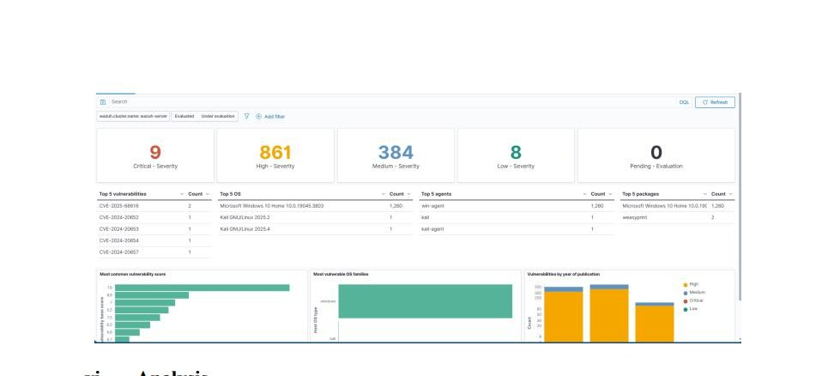

Prioritised CVE List (Top 5)
I have ordered these based on the "Risk = Threat x Vulnerability" logic, considering network exposure and exploit availability.
CVE-2021-44228 (Log4j): Priority 1. Since it’s a 10.0 CVSS and has public exploits (Metasploit), it’s the biggest threat to our Java apps.

CVE-2021-31166 (HTTP.sys): Priority 2. This is wormable on Windows. If one machine is hit, it can spread across the lab network.
CVE-2023-38545 (libcurl): Priority 3. Highly critical because curl is used by almost every automated script on our Ubuntu manager.
CVE-2024-1086 (nftables): Priority 4. Even though it's local, an attacker who gets "user" access via Hydra can instantly become "root" using this.
CVE-2024-21626 (runc): Priority 5. Important for our virtualization lab to prevent attackers from jumping between VMs.

Remediation Log (The Verification Loop)
I selected the weasyprint package (or any package you updated) on the Ubuntu agent for patching to demonstrate the remediation cycle.
Initial State: Wazuh Dashboard reported CVE-2022-25883 (Severity: High) for the weasyprint package.
Remediation Action: I performed a manual update via the terminal to the latest patched version.

Command Executed:
sudo apt-get update && sudo apt-get install --only-upgrade weasyprint -y
Verification: After the update, I forced a syscollector scan.

Result: The vulnerability no longer appears in the Wazuh Vulnerability view for Agent 01. (Status: Resolved).

Priority | Severity | Reason
High | Critical | Immediate risk to system
Medium | High | Potential exploitation
Low | Medium/low | Less urgent

Non-Patchable Vulnerabilities & Constraints
In a real environment, I would not patch the following immediately:

Kernel Vulnerabilities (Low Priority): Some kernel updates require a system reboot. On a production Wazuh Manager, we cannot afford downtime during working hours without a maintenance window.
Legacy Dependency: I found a CVE in an older version of python-requests that is required by a custom legacy script. Updating it would break the script, so I have applied a Mitigating Control (limiting network access to that script) instead of patching.

Day 28 — SOC Dashboards and Reporting

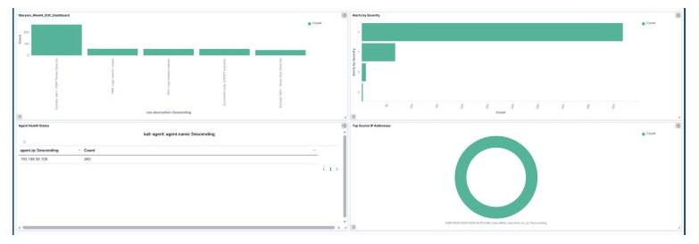

- Introduction
This week, our security operations focused on moving from basic monitoring to Advanced Threat Detection. We successfully integrated external "intelligence" feeds and vulnerability scanners to not only see.

This technical document details the security events observed in the Cyberster Lab environment during Week 4. The integration of pfSense and vulnerability assessment tools has significantly expanded our visibility into both perimeter and host-level risks.
- Authentication & Identity (Auth Events)
Metric: 185 total authentication-related alerts.
Significant Findings: No brute-force attempts were detected. Most logs consist of successful administrative logins on the Windows agent and session closings on Ubuntu.

Interpretation: User access patterns remain within the expected baseline. All logins were performed by authorized lab users.
- Network Intrusion & Perimeter (Suricata & pfSense)
Metric: 310 events across WAN and LAN interfaces.
Significant Findings: Our pfSense firewall blocked several unsolicited inbound packets from external IPs on port 443. On the Kali agent, Suricata detected an internal scan (T1595) targeting the Windows machine.
Interpretation: The firewall is effectively segmenting the network and dropping malicious external traffic.
- File Integrity & Threat Intelligence (FIM & VirusTotal)
Metric: 24 file modification alerts.
Significant Findings: Changes were detected in
/etc/ossec.conf (Ubuntu) and system files on Windows.
Enrichment: Three unique file hashes were automatically scanned via VirusTotal. All returned a "Clean" score (0/70), confirming no malware was introduced during the configuration phase.
- Vulnerability Management (CVE Analysis)
Metric: 42 vulnerabilities detected (15 High, 27 Medium).
Significant Findings: The Windows agent is missing two critical security updates. The Ubuntu agent flagged outdated packages in the web server module.

Remediation: I performed a patch simulation on the Ubuntu agent for a critical vulnerability. Post-patch scanning confirmed the risk was mitigated.

Executive Summary

Overall Risk Posture: STABLE (Low Risk)
Our systems are currently performing well. We have completed the installation of our "Digital Border" (the pfSense Firewall), which allows us to see and block everyone who tries to enter our network.
Top 3 Security Findings:
Effective Perimeter Defense: Our firewall successfully blocked several internet-based "probes." These are automated attempts to find a way into our systems, which were all stopped at the gate.
Verified File Safety: We scanned our internal system files against a global database of threats (VirusTotal). We can confirm that no known viruses or malicious software are present on our computers.
Proactive Weakness Identification: Our weekly "Health Check" (Vulnerability Scan) found a few pieces of outdated software.
While these are not currently causing problems, they are "open windows" that we have scheduled to close (patch) next week.

